Set A
- a) Define a class patient (patient_name, patient_age, patient_oxy_level,patient_HRCT_report). Create an object of patient. Handle appropriate exception while patient oxygen level less than 95% and HRCT scan report greater than 10, then throw user defined Exception “Patient is Covid Positive(+) and Need to Hospitalized” otherwise display its information.

- import java.util.*;

- class HealthException extends Exception {
- String msg = "I'm sorry ! Your'e Covid Positive(+) \n Need to Hospitalized\n";

- public String toString() {
- return msg;
- }
- }

- class patient {
- String pname;
- byte page;
- int p_oxy_level;
- int p_HRTC_report;

- patient(String p, byte a, int ol, int pr) {
- pname = p;
- page = a;
- p_oxy_level = ol;
- p_HRTC_report = pr;
- }

- public void display() {
- System.out.println("\n\t\tPatient Details\n");
- System.out.println("\tPatient Name\tPatient Age\tOxygen_level\tHRTC_Report");
- System.out.println("\t" + pname + "\t\t" + page + "\t\t" + p_oxy_level + "\t\t" + p_HRTC_report);
- }
- }

- public class Hospital {
- public static void main(String[] args) {
- Scanner sc = new Scanner(System.in);

- try {
- System.out.println("Enter Patient Name: ");
- String pn = sc.nextLine();

- System.out.println("Enter Patient Age: ");
- Byte pa = sc.nextByte();

- System.out.println("Enter Oxygen Level: ");
- int ol = sc.nextInt();

- System.out.println("Enter HRTC Report: ");
- int pr = sc.nextInt();
- patient p = new patient(pn, pa, ol, pr);

- if (p.p_oxy_level < 95 && p.p_HRTC_report > 10) {
- throw new HealthException();

- }
- p.display();

- } catch (Exception e) {
- System.out.println(e);
- }

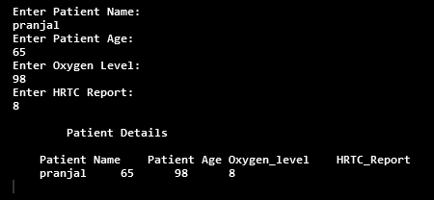
- sc.close();

- }
- }

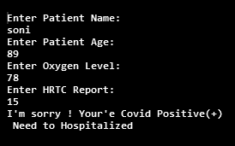
Output:-

c)Accept the names of two files and copy the contents of the first to the second.
First file having Book name and Author name in file. Second file having the contents
of First file and also add the comment ‘end of file’ at the end.

import java.io.FileReader;
import java.io.FileWriter;
import java.io.IOException;
public class GFG {
public static void main(String[] args)
{
try {

FileReader fr = new FileReader("gfgInput.txt");
FileWriter fw = new FileWriter("gfgOutput.txt");
String str = "";

int i;
while ((i = fr.read()) != -1) {
str += (char)i;
}
System.out.println(str);
fw.write(str);
fr.close();
fw.close();
System.out.println(
"File reading and writing both done");
}
catch (IOException e) {
System.out.println(
"Hello TYBCS");
}
}
}
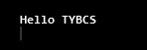
Output:-

- c) Define a class MyDate (day, month, year) with methods to accept and display a MyDate object. Accept date as dd, mm, yyyy. Throw user defined exception “InvalidDateException” if the date is invalid.
Examples of invalid dates : 03 15 2019, 31 6 2000, 29 2 2021
import java.util.Scanner;
class InvalidDateException extends Exception {
String msg = "Invalid date....\nTry Again\n";
public String toString() {
return msg;
}
}
class MyDate {
int day, mon, yr;
MyDate(int d, int m, int y) {
day = d;
mon = m;
yr = y;
}
void display() {
System.out.println("\n\t\tDate\n");
System.out.println("\t----------------------");
System.out.println("\tDay\tMonth\tYear");
System.out.println("\t----------------------");
System.out.println("\t" + day + "\t" + mon + "\t" + yr);
System.out.println("\t----------------------");
}
}
public class DateException {
public static void main(String arg[]) {
Scanner sc = new Scanner(System.in);
System.out.println("Enter Date : dd mm yyyy ");
int day = sc.nextInt();
int mon = sc.nextInt();
int yr = sc.nextInt();
int flag = 0;
try {
if (mon <= 0 || mon > 12)
throw new InvalidDateException();
else {
if (mon == 1 || mon == 3 || mon == 5 || mon == 7 || mon == 8 || mon == 10 || mon == 12) {
if (day >= 1 && day <= 31)
flag = 1;
else
throw new InvalidDateException();
} else if (mon == 2) {
if (yr % 4 == 0) {
if (day >= 1 && day <= 29)
flag = 1;
else
throw new InvalidDateException();
} else {
if (day >= 1 && day <= 28)
flag = 1;
else
throw new InvalidDateException();
}
} else {
if (mon == 4 || mon == 6 || mon == 9 || mon == 11) {
if (day >= 1 && day <= 30)
flag = 1;
else
throw new InvalidDateException();
}
}
}
if (flag == 1) {
MyDate dt = new MyDate(day, mon, yr);
dt.display();
}
} catch (InvalidDateException e) {
System.out.println(e);
}
}
}
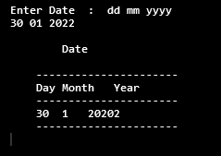
Output;-

Set C
- Write a menu driven program to perform the following operations on a set of integers as shown in the following figure. A load operation should generate 10 random integers (2 digit) and display the number on screen. The save operation should save the number to a file “number.txt”. The short menu provides various operations and the result is displayed on the screen.

import java.io.*;
import java.util.*;

public class FileMenu {
public static void main(String[] args) {
try {
FileOutputStream fout = new FileOutputStream("number.txt");
FileReader fr = new FileReader("number.txt");
Scanner sc = new Scanner(System.in);
int choice, n;
String num = "";
do {

System.out.println("\n\n\tFile Menu\n");
System.out.println("1. Generate and Disply Numbers");
System.out.println("2. Save Numbers in file");
System.out.println("3. View File Content");
System.out.println("4. Exit");
System.out.println("Enter Your Choice");
choice = sc.nextInt();
switch (choice) {
case 1:
Random r = new Random();
for (int i = 0; i < 10; i++) {
n = r.nextInt(99);
num += n + " ";
System.out.print(n + " ");
}
break;
case 2:
byte b[] = num.getBytes();
fout.write(b);
System.out.println("\n\tFile Content Saved");
fout.close();
break;
case 3:
int ch;
System.out.println("\n\tFile Content\n");

while ((ch = fr.read()) != -1) {
System.out.print((char) ch);
}
fr.close();

break;
case 4:
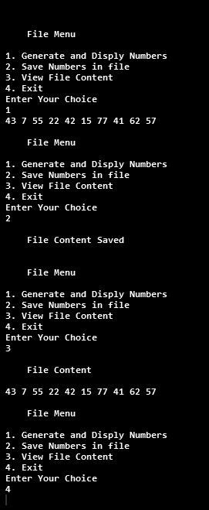
System.exit(0);
break;
}// switch
} while (choice != 4);
} catch (Exception e) {
System.out.println(e);

}
}
}

Output:-

- b) Write a java program to accept Employee name from the user and check whether it is valid or not. If it is not valid then throw user defined Exception “Name is Invalid” otherwise display it.(Name should contain only characters)

import java.util.Scanner;

class NameisInvalid extends Exception {
String msg = "\nInvalid Name....\nName should contain only characters\nThank You :)\n";

public String toString() {
return msg;
}
}

class Employee {
String name;

Employee(String name) {
this.name = name;
}
}

public class EmployeeException {
public static void main(String[] args) {
Scanner sc = new Scanner(System.in);

System.out.println("Enter Name :");
String name = sc.nextLine();

try {
for (int i = 0; i < name.length(); i++) {
int ch = (int) name.charAt(i);

if ((ch >= 65 && ch <= 90) || (ch >= 97 && ch <= 122)) {
} else {
throw new NameisInvalid();
}
}

System.out.println("\nEmployee Name:-" + name +"\n");

} catch (NameisInvalid e) {
System.out.println(e);
}

}
}

Output:-
